**MEAN STACK APPLICATION – Lab 5**

Name: Naga Sirisha Sunkara

Class ID:40

Lab ID:7-2

Email:[nsbz5@mail.umkc.edu](mailto:nsbz5@mail.umkc.edu)

Technical Partners details:

Name:Vinay Santhosham

Class ID:32

Email:[vsvzw@mail.umkc.edu](mailto:vsvzw@mail.umkc.edu)

Professor: Yug Yung Lee

Github link for the source code:

https://github.com/sirisha1206/CS5551_7-2_labassignments/tree/master/Lab5/Source

The main purpose of this assignment is to create a MEAN stack application and perform CRUD operation.

In this application we have created a login ,register and home page.

**MongoDB:**

To use the mongoDB we nedd to create the mlab acoount and create a database in it and use the mongodb://:@ds121955.mlab.com:21955/sirishasunkara for our application.

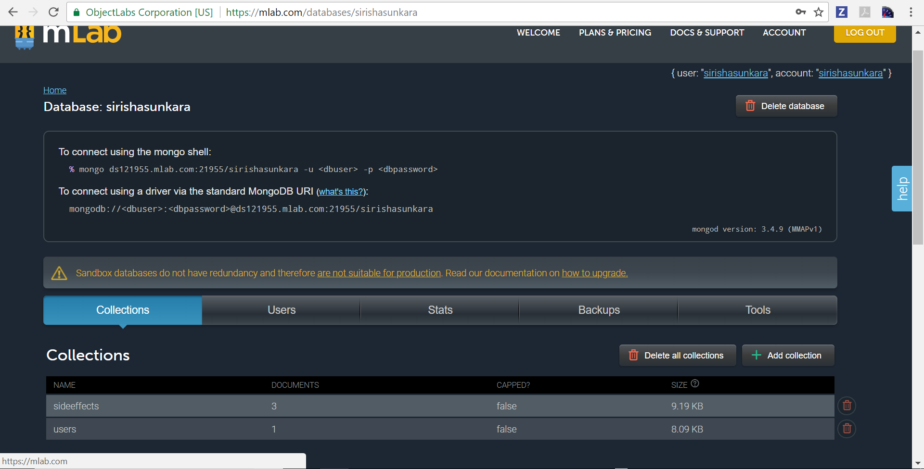

**Register Page:**

In the register page user needs to enter the username and password and click on register.Then the user details are saved into the mongoDB.

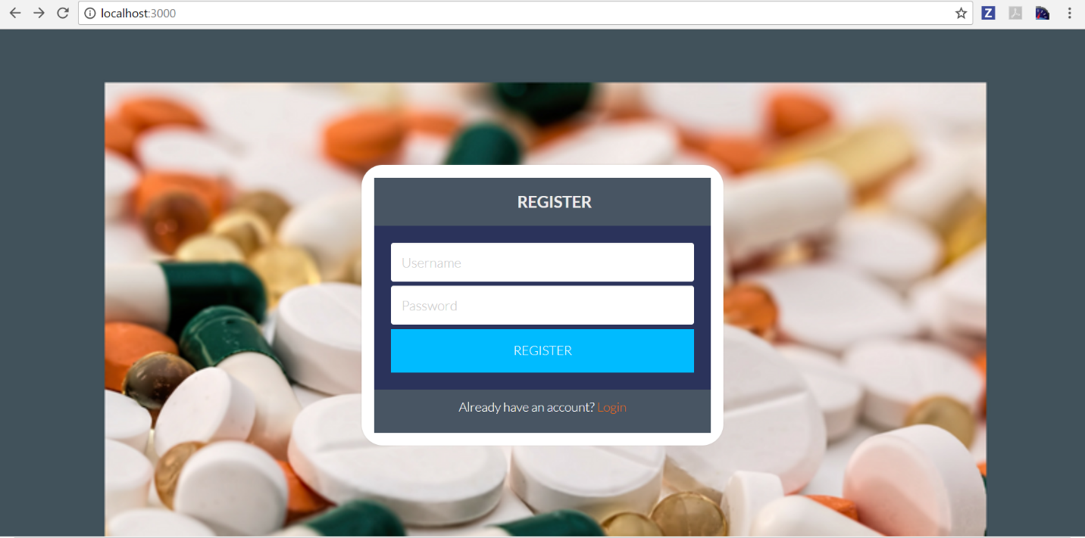

Once the user clicks on register button its displays the alert showing that data is saved to the database.

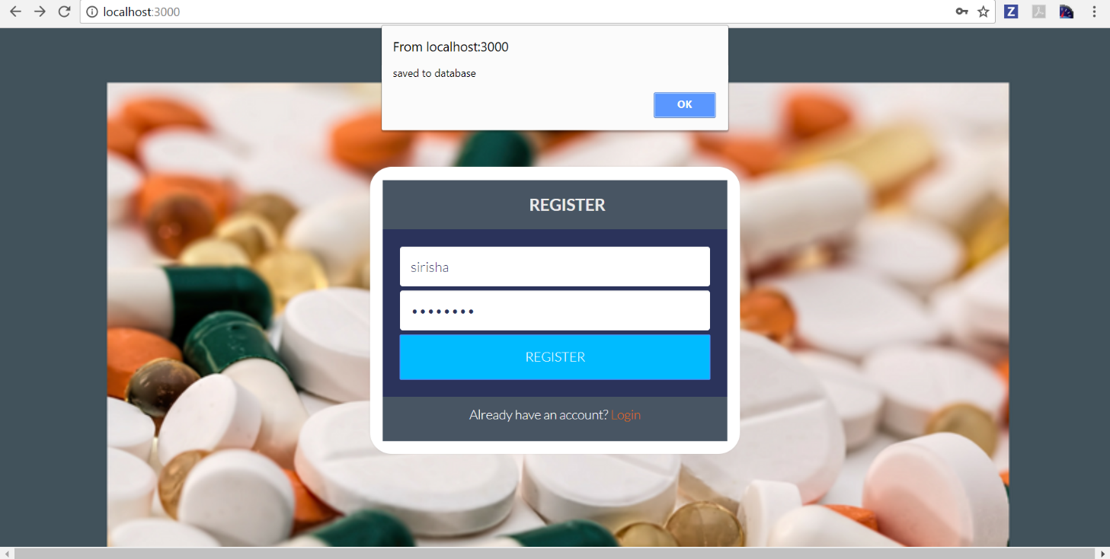

User details are saved into the users collection in the database.The following screenshot shows the users in the database.

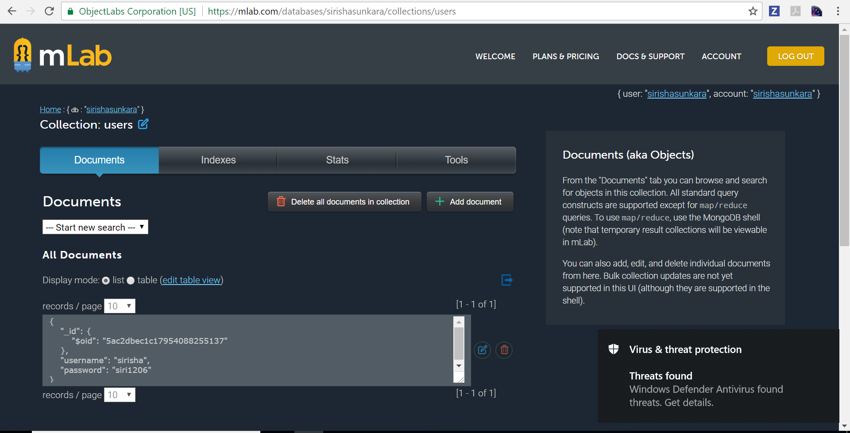

**Login Page:**

Now the user can login with the details stored in the database.It redirects to the home page.

The following screenshot shows the login page of the application.

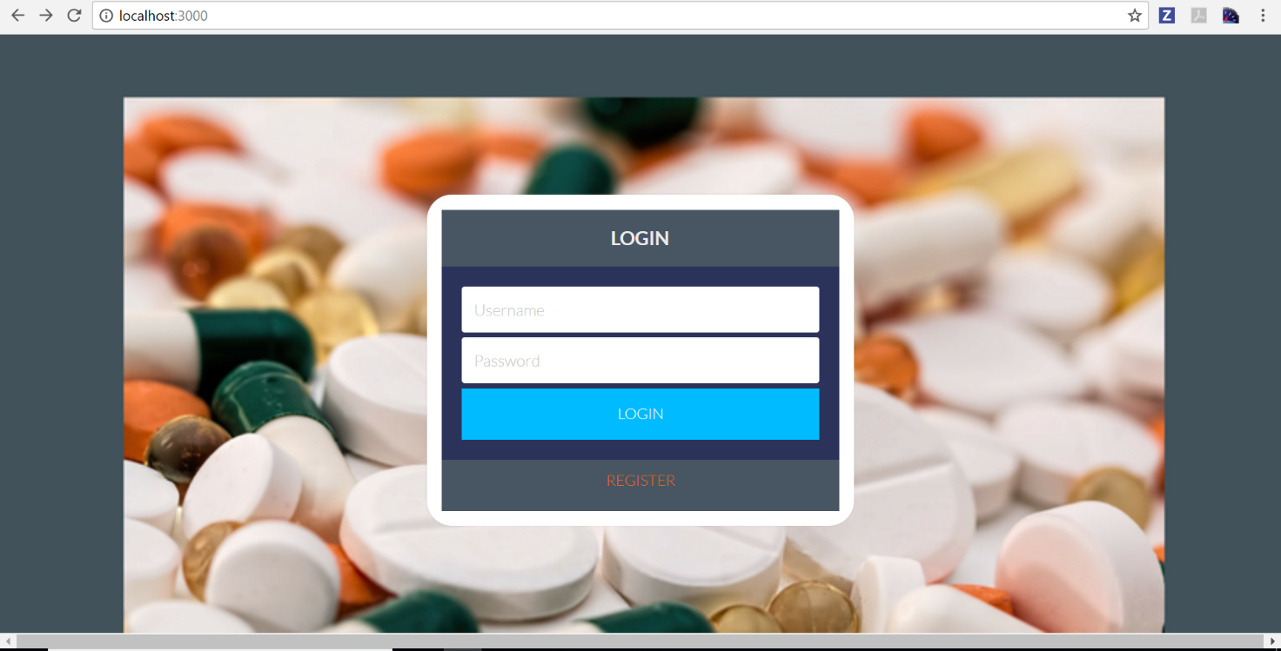

The following screenshot shows the home page of the application.

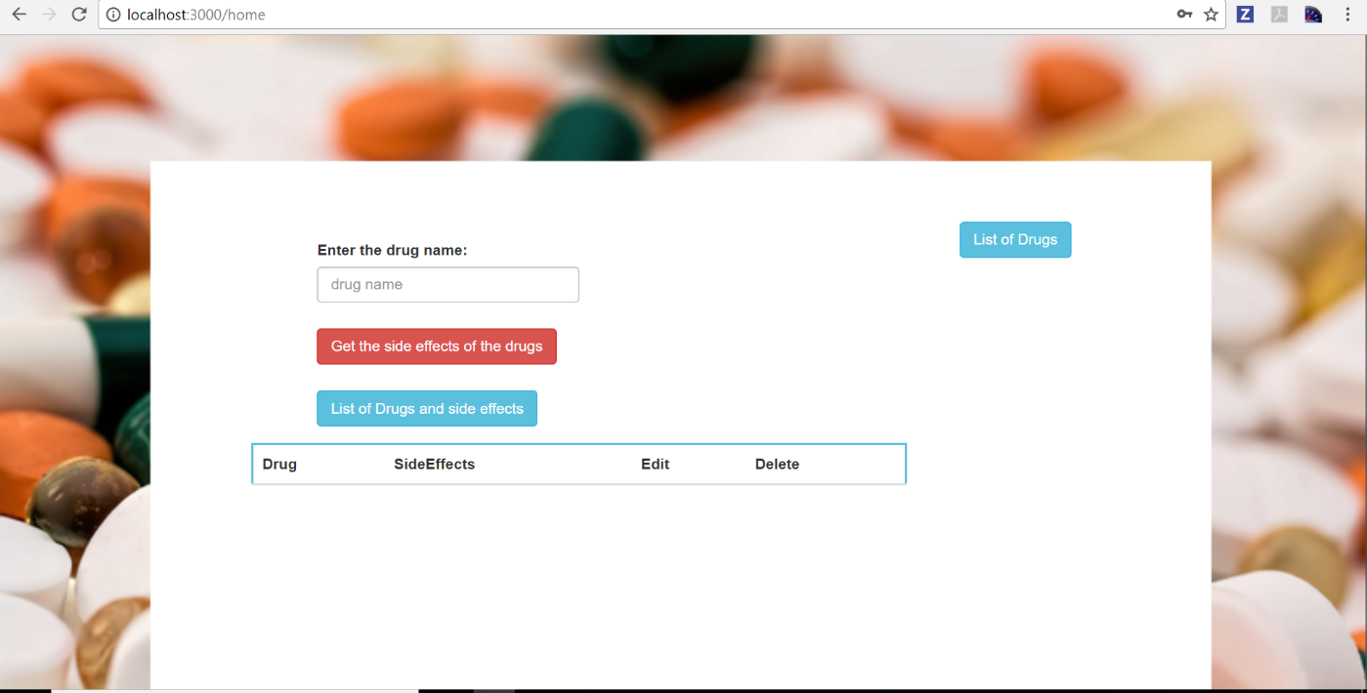

**Home Page:**

The functionality of the home page is to display the side effects of the drugs and perform CRUD operations.

As the user may have ambiguity in knowing the drugs names we have used the 'drugs' node module to display the list of drugs.For this we created the '/drugslist' URL to get the data from the Node JS.

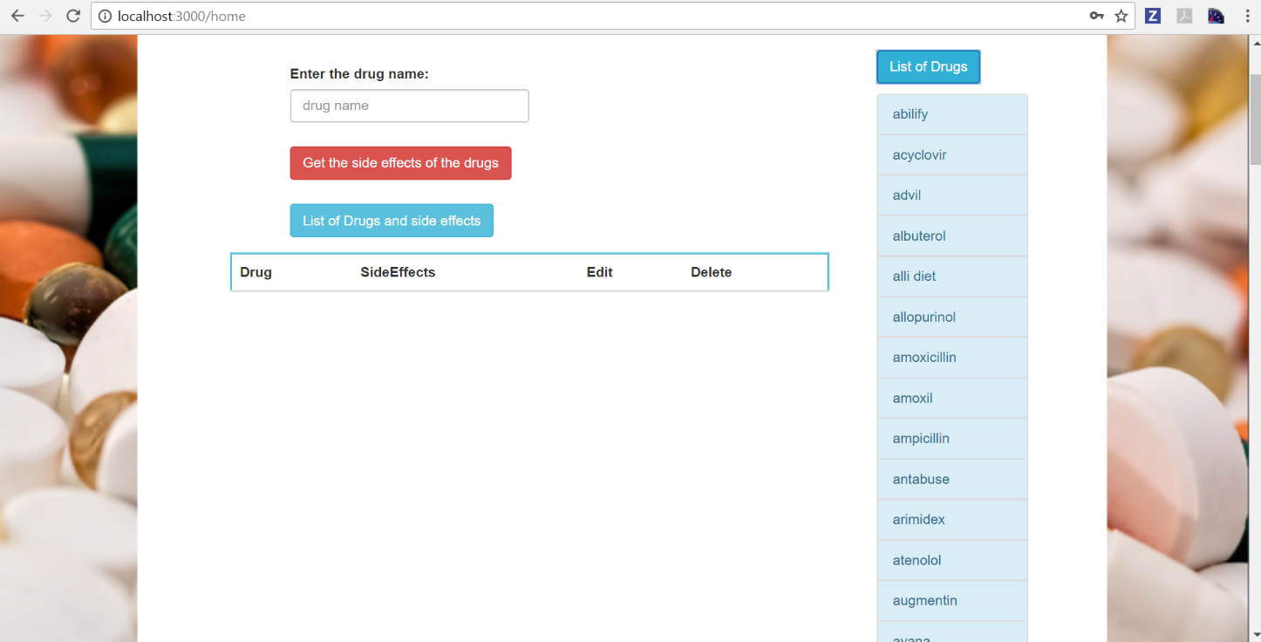

The following screenshot shows the node modules used for the application.

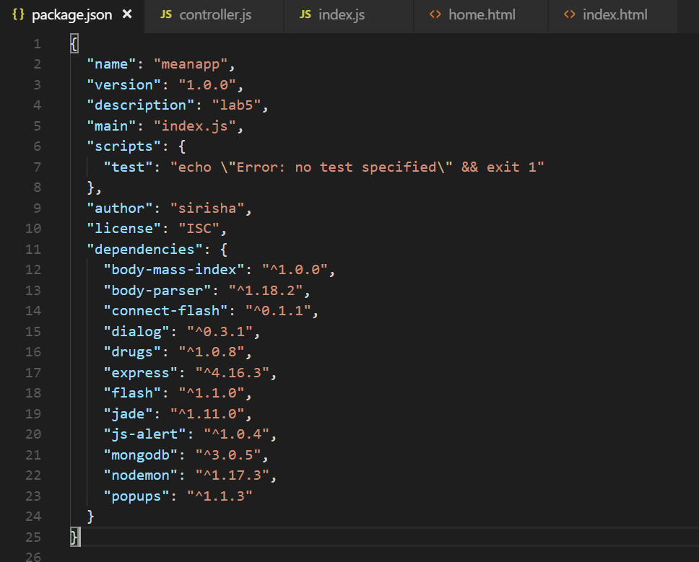

**CRUD Operations:**

**CREATE:**

For create operation we need to enter the drug name in the input text field and click on 'Get the side effects of the drugs' button.To get the side effects of the drugs we have used the openFDA API and parsed the json from this api and sent it to the database with '/sideeffects' URL and stores it in sideeffects collection. The following screenshots shows the ui after inserting the data.

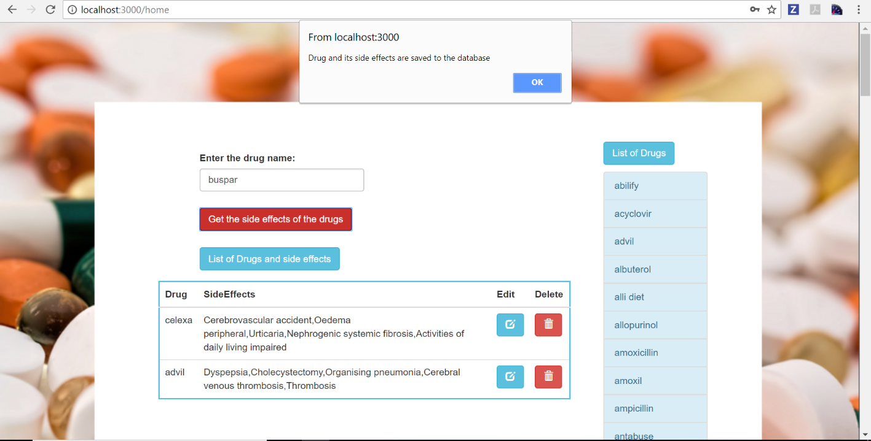

The following screenshot shows the data in the database after inserting.

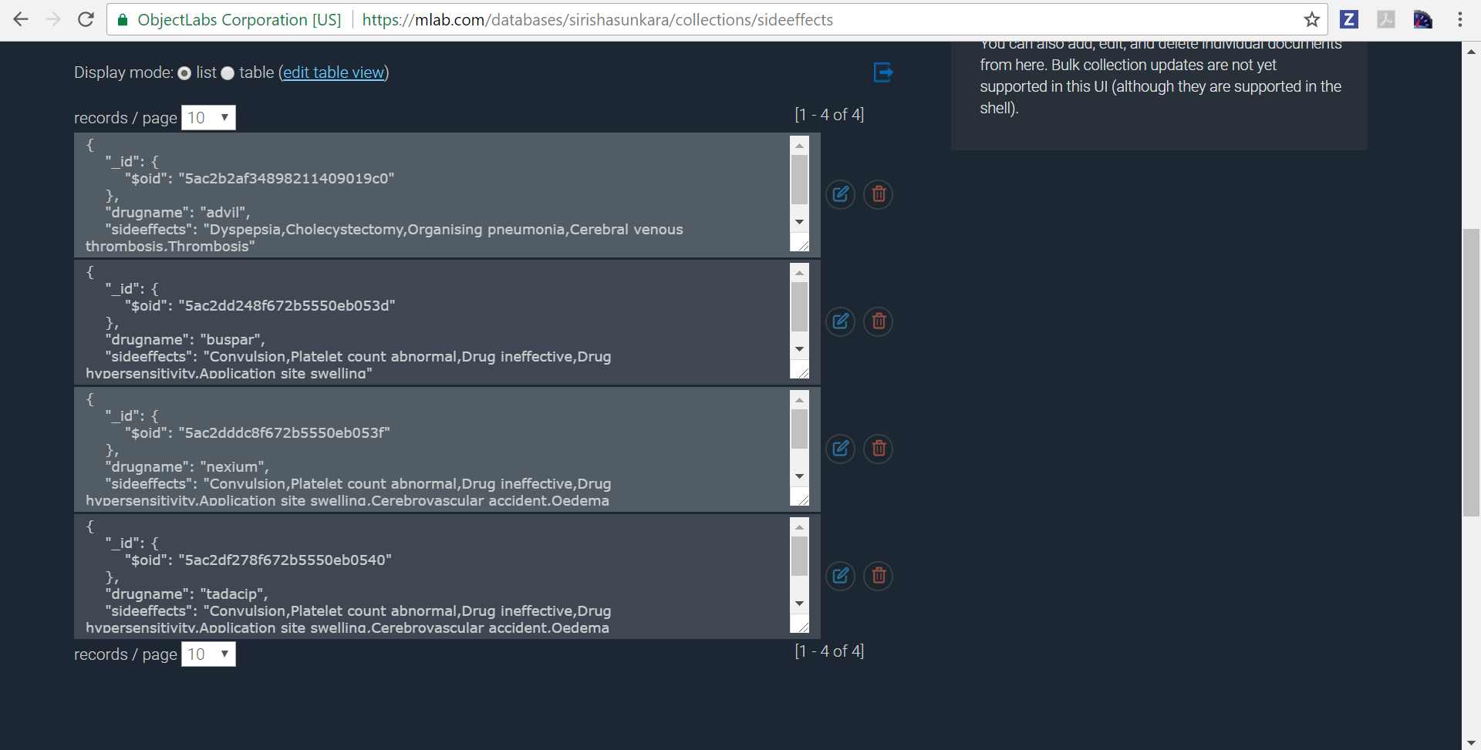

Angular JS code for create operation:

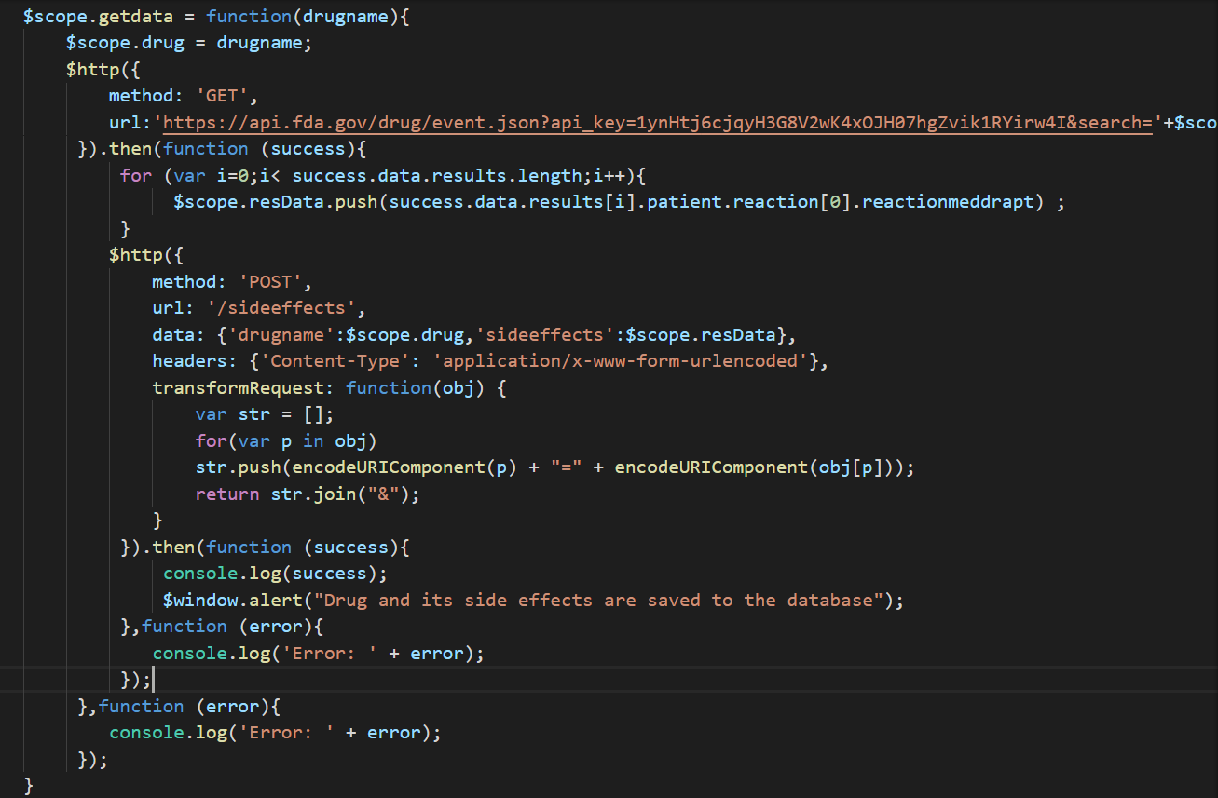

Node JS code for create operation:

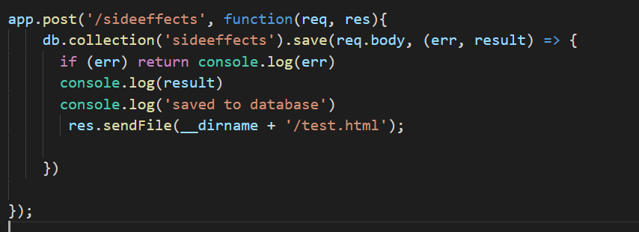

**READ:**

To perform read operation we need to click on 'List of drugs and side effects' button.It sends the get request through '/drugseffectslist' URL and gets the data from mongodb from sideeffects collection.It displays the recieved data in the form of table with option to update and delete the row.

The following screenshot shows the list of drugs and its side effects.

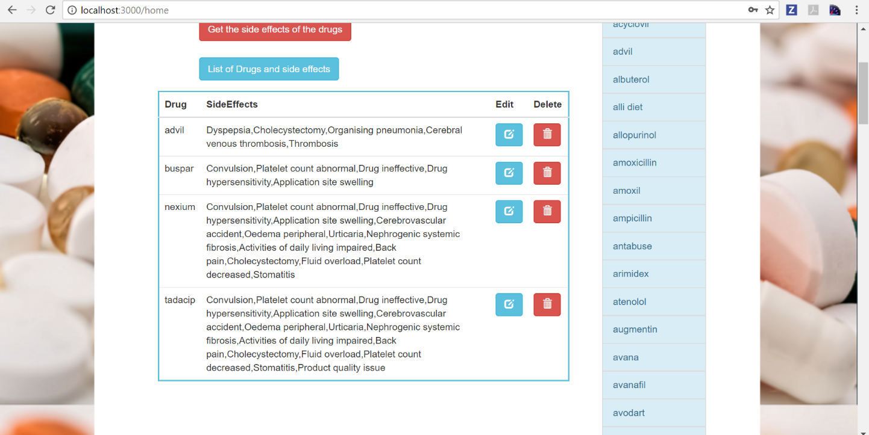

Angular JS code for read operation:

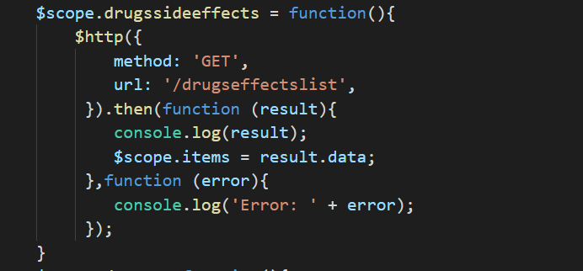

Node JS code for read operation:

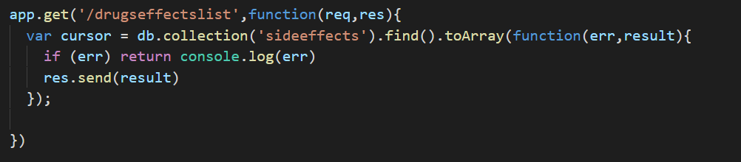

**UPDATE:**

When the user clicks on the edit button ,a modal is displayed in which we need to enter the modified values and send the data to the mongoDB through '/updateData' URL.

The following screenshot shows the modal displayed when the user clicks the edit button.

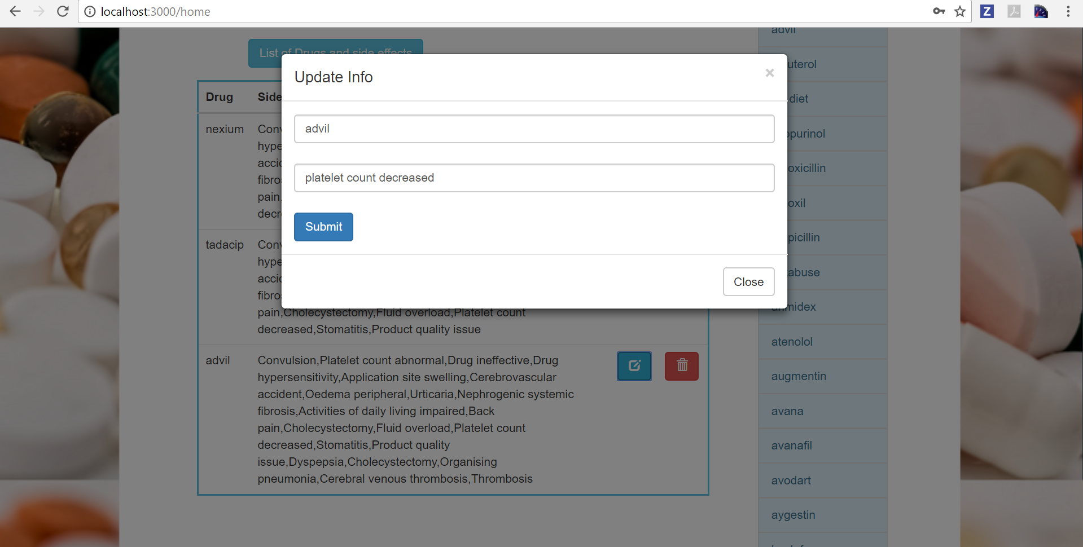

The following screenshot displays the alert after updating the drug data.

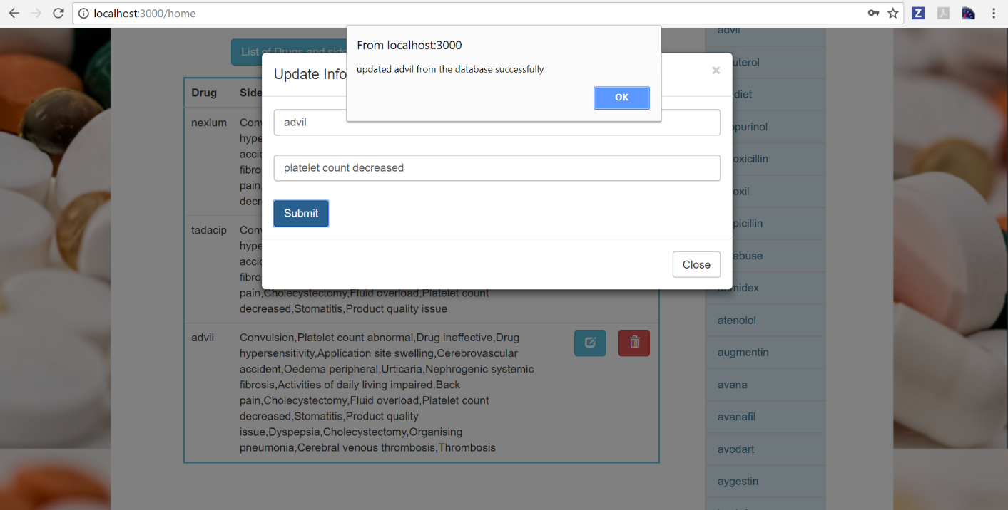

The following screenshot displays the data in the UI after updating.

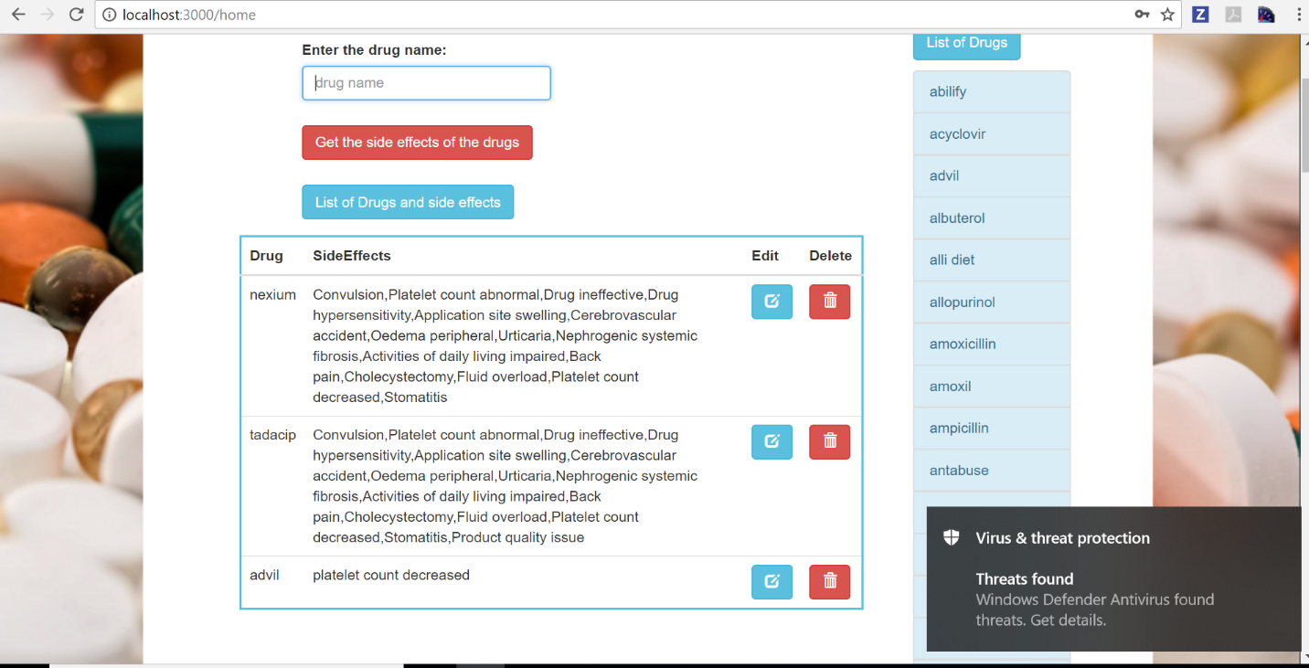

The following screenshot shows the data in the mongodb after updating.

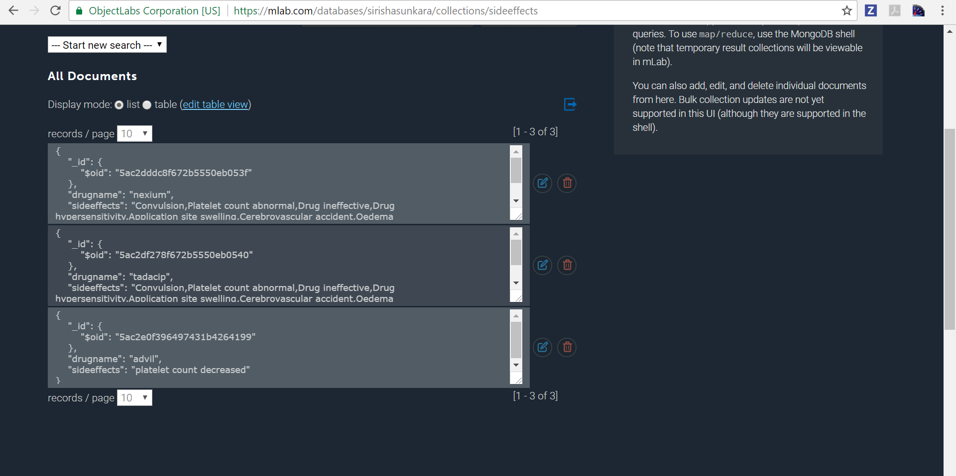

Angular JS code for update operation:

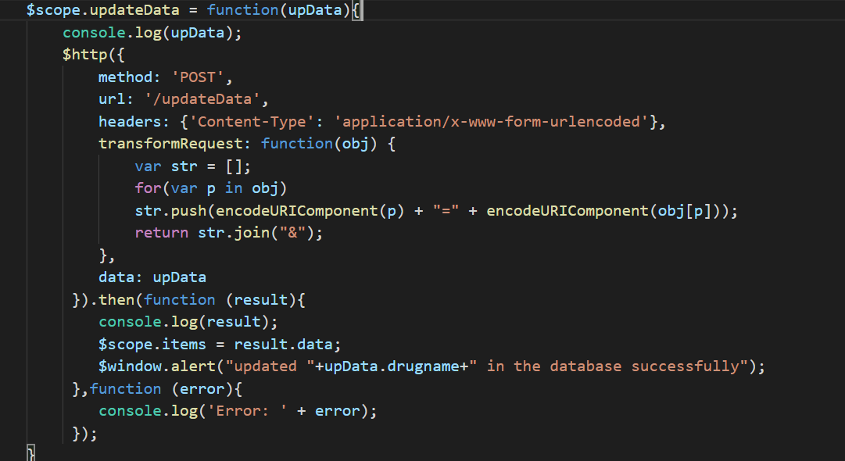

Node JS code for update operation:

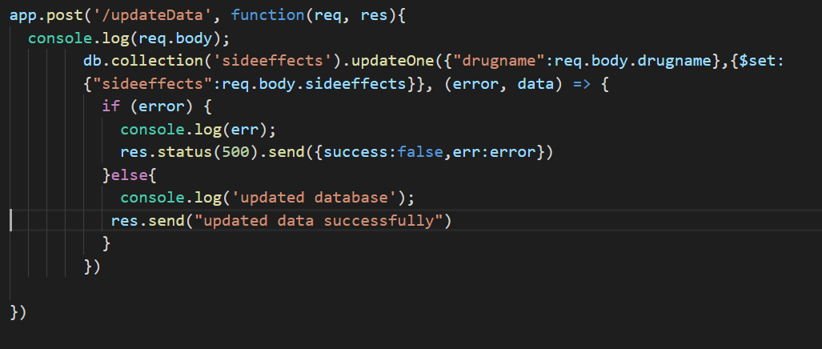

**DELETE:**

Clicking on the delete button in the table it deletes that particular row.The request is sent through the '/deleteData' URL.

The following screenshot shows the ui after user clicks on delete button.

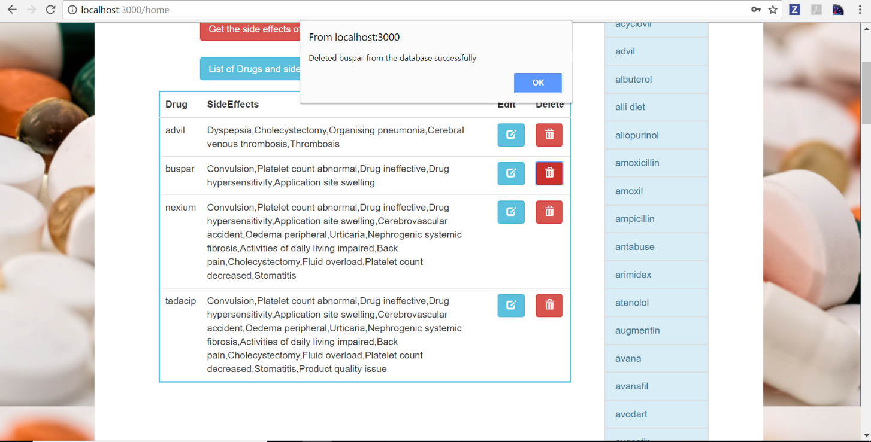

The following screenshot shows the data in the mongodb after deletion.

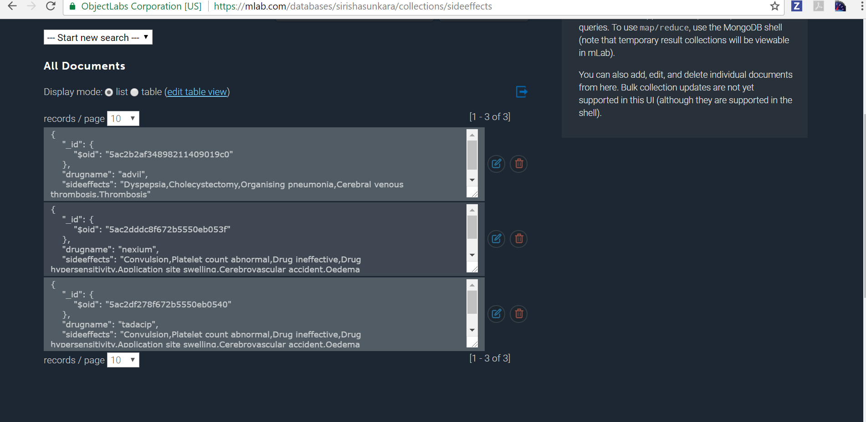

The following screenshot shows list of drugs and its side effects after deletion.

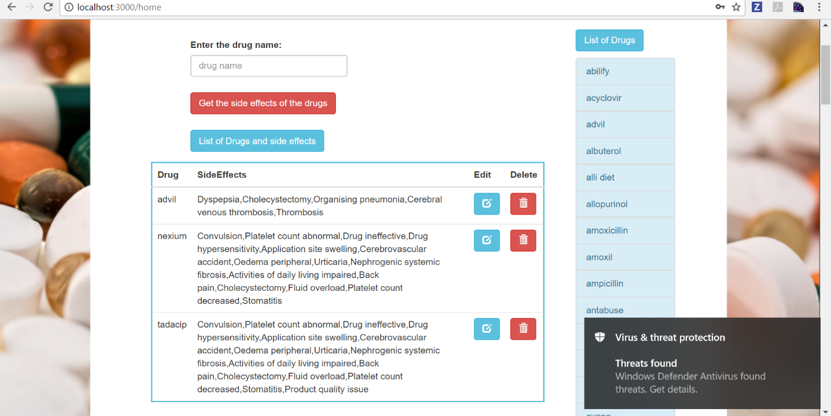

Angular JS code for delete operation:

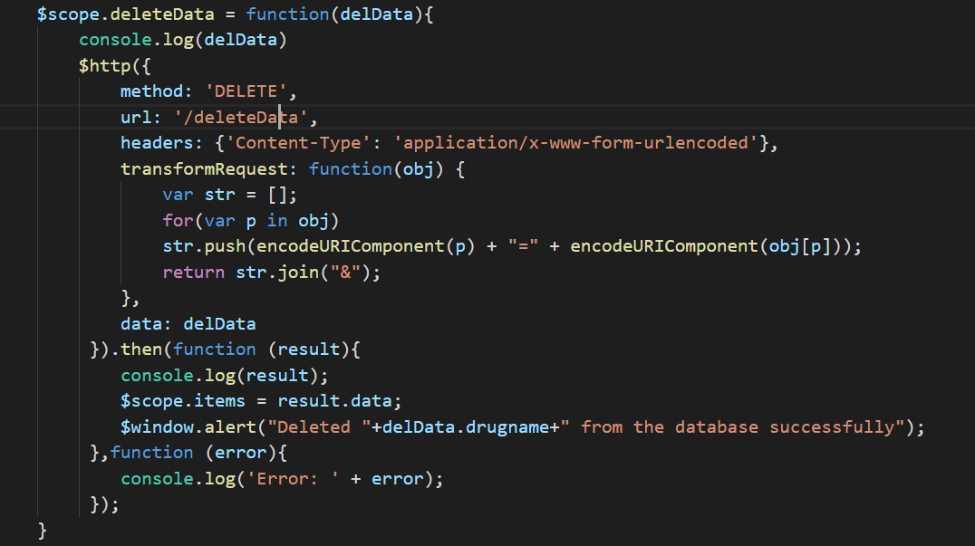

Node JS code for delete operation:

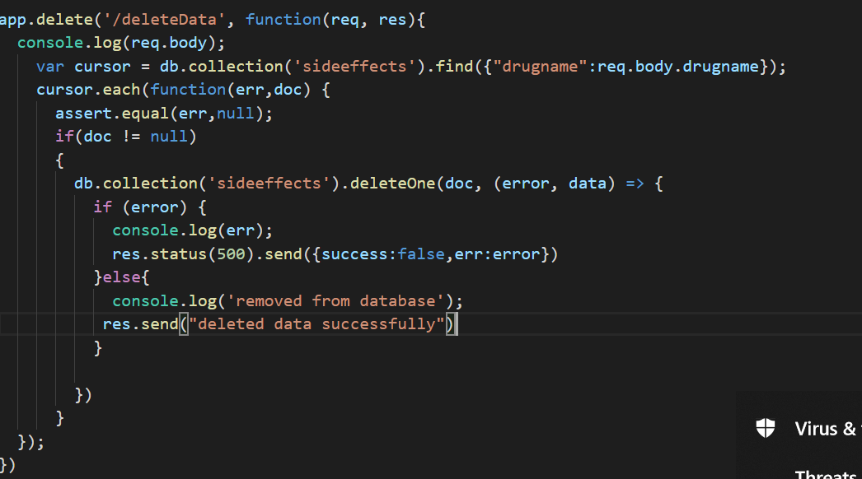

The following screenshot shows all the request in network.

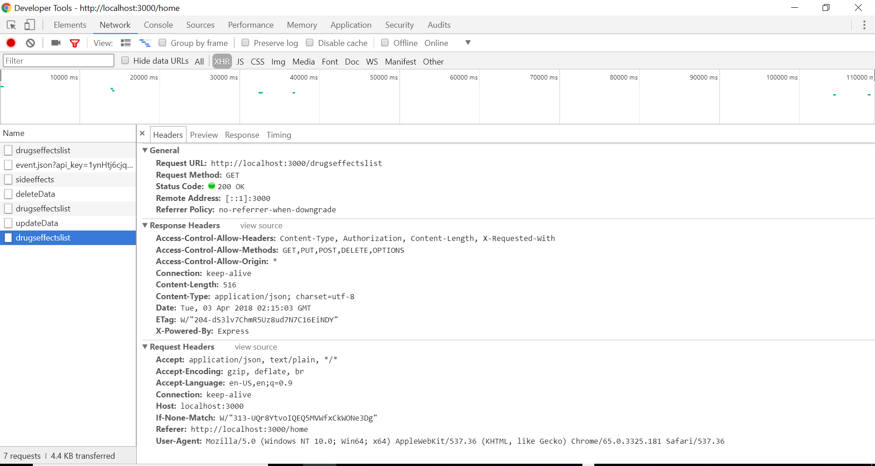

To start the server we used nodemon node module which restarts the server automatically if there are any changes in the node js server file.

